A Walk in Her Shoes
My Sister’s House
Corporate Sponsorships

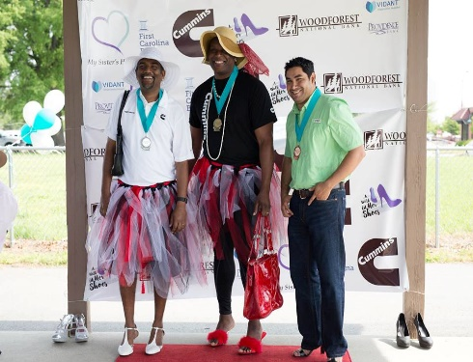
Every 98 seconds an American is sexually assaulted, and every 8 minutes that victim is a child. My Sister’s House (MSH) has served this community since 1981, and is the only provider of services for sexual assault victims in Nash and Edgecombe Counties.

Every April, in honor of Sexual Assault Awareness Month, MSH hosts “A Walk in Her Shoes” where men from the community take a walk in high heels to show support for victims of sexual assault. This walk helps to raise awareness for sexual assault, the services provided by MSH, and funding for those services.

Sponsorship Levels:

Event Banner Sponsor $250
-Business logo included on event banner used for event photographs
-Acknowledgement at the event, on social media, website, and press releases

Social Media Sponsor $100
-Acknowledgement at the event, on social media, and website

The deadline to have your company logo on the event banner is March 28th at 5pm

We also encourage everyone to consider walking with us in support of “A Walk in Her Shoes”. Walkers may register online (http://www.mshnc.org/a-walk-in-her-shoes) or by phone (252) 316-8444.

Please provide a corporate logo to be included on the banner and send to Emily Lemus at elemusmsh@suddenlinkmail.com. If possible, an electronic logo in .pdf or .vector format will ensure that your logo is crisp and easy to read!

Company Name: Phone:

Address: Email:

Select Sponsorship Level:

( ) Event Banner Sponsor ($250) ( ) Social Media Sponsor ($100)

